30 June is the deadline to participate in the 2nd innovation fair entitled “Made in Egypt”
18-6-2023
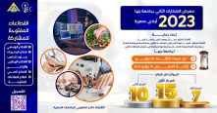
Under the auspices of Prof.Dr. Gamal Sosa, BU president, Prof.Dr. EL-Sayed Fouda, the vice president of community service and environment development, the innovation and entrepreneurship center in Benha University announces that the deadline for the Egyptian Universities’ students to participate in the 2nd innovation fair entitled “Made in Egypt” will be at the end of June. It’s noteworthy that the fair will be held in 10th of July in 2023.
Benha University participates in the national dialogue sessions
18-6-2023
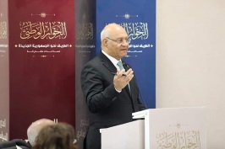
Prof.Dr. Gamal Sosa, BU president and Prof.Dr. Nasser EL-Gizaway, the vice president of post-graduate studies and research participate in the national dialogue third-week sessions. The University participates in the economic sessions, as the University president talks in the committee of agriculture and the food security in which the state’s role in providing production materials and setting prices in addition to boosting agriculture and insurance is discussed publically.
New appointments in Benha University
18-6-2023
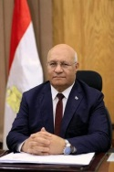
Prof.Dr. Gamal Sosa, BU president issues a number of decrees to appoint new departments’ heads in the University’s faculties. Prof.Dr. Anwar Abdel Fattah Abdel Malak, the professor of Anatomy department is appointed as the department head in the faculty of veterinary medicine and Prof.Dr. Ayman Ali Ahmed, the professor of curricula and the methodology is appointed as the department head in the faculty of physical education. The decrees also include the secondment of Eng. Ahemd Mohy Mohamed to be the general manager of the engineering affairs in the faculty of engineering/ Shubra.
Benha University celebrate the international day of blood donation
18-6-2023
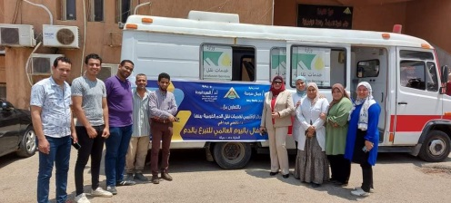
The sector of community service and environment development organizes, under the auspices of Prof.Dr. Gamal Sosa, BU president and Prof.Dr. EL-Sayed Fouda, the vice president of community service and environment development, a ceremony to celebrate the international day of blood donation that corresponds to 14-6-2023.
This ceremony is held in the presence of Prof.Dr. Nermin Adly, the vice dean of community service and environment development, Prof.Dr. Nancy Abdel Hay, the head of the regional center for blood donation services in Qulubia governorate and Ms. Rania Motaaz, the assistant secretary-general of community service and environment development.
Signing a cooperation protocol between the faculties of specific education in Benha and EL-Minofya Universities
21-6-2023
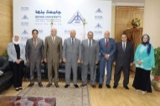
Prof.Dr. Gamal Sosa, BU president and Prof.Dr. Ahmed EL-Kasad, the president of EL-Minofya University sign a cooperation protocol between the faculties of education in Benha and EL-Minofya Universities with regard to students exchange and mutual cooperation. This is done in the presence of Prof.Dr. Tamer Samir, THE vice president of students and educational affairs, Prof.Dr. Tayia Abdel EL-Latif, the chancellor of the minister of higher education for students’ activities, Prof.Dr. Mohamed Ibrahim, the dean of the faculty of specific education, Prof.Dr. Mohamed Zidan/ Benha, the dean of the faculty of specific education/ EL-Minofya, Prof.Dr. Ghada Shaker, the vice dean of the faculty of specific education for students and educational affairs (Benha) and Prof.Dr. Hayam Mustafa, the vice dean of the faculty of specific education for students and educational affairs (El-Minofya).

The faculty of arts (Media department) conducts discussions with the department’s graduates with regard to their discussion projects (Radio section) for class 2023
21-6-2023
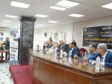
Under the auspices of Prof.Dr .Gamal Sosa, BU president, Prof.Dr. Tamer Samir, the vice president of education and students’ affairs and Prof.Dr. Mohamed Abu Arab, the acting dean, the faculty of arts (Media department) conducts discussions with the department’s graduates with regard to their discussion projects (Radio section) for class 2023. This is done in the presence of Prof.Dr. El-Arabi EL-Tohki, the vice dean of community service and environment development, Prof.Dr. Somaya Arafat, the department head. The panel includes Mr. Mohamed Helal, the head of the channel 3, Mr. Mohamed Sayed EL-Ahl, the T.V director and the head of educational programs, Prof.Dr. Mohamed Abu Cup, the head of the digital transformation institution and Prof.Dr. Mohamed EL-Shawady.
Ministerial decrees to renew appointment of four general managers in Benha University
14-6-2023
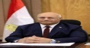
Prof.Dr. Gamal Sosa, BU president announces that there are Ministerial decrees to renew appointment of four general managers in Benha University. These decrees include the renewal of Ms. Rania Motaaz as the assistant secretary-general of community service and environment development, Prof.Dr. Awaad Allah Soliman as the head of the University hostels and nutrition, Mr. Ahmed Ragab as the head of the scientific and cultural relations and renew the appointment for Mr. Mohamed Mahmoud as the head of the University libraries.
BU president attends the initiative of planting the fruitful trees in the faculty of science
14-6-2023
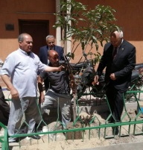
Prof.Dr. Gamal Sosa, BU president attends the initiative of planting the fruitful trees in the faculty of science so as to increase the green spaces inside the University campus. This is done in the presence of Prof.Dr. Lofty Abu Salim, the faculty dean and the vice deans and a number of the faculty’s members. The University president stresses that this initiative comes in accordance with the societal role of the university plays in serving the community and developing the environment.
BU president inspects the exams halls in three faculties
12-6-2023
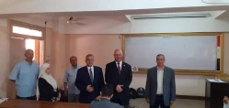
Prof.Dr. Gamal Sosa, BU president tours the exams halls in the faculty of nursing, the faculty of engineering/ Benha and the faculty of science to make sure that everything, regarding the 2nd semester exams, are up and running. This tour is conducted in the presence of Prof.Dr. Marwa Mustafa, the dean of the faculty of nursing, Prof.Dr. EL-Sayed Ali, the dean of the faculty of engineering/ Benha, Prof.Dr. Lofty Abu Salim, the dean of the faculty of science, Prof.Dr. Mohamed Abdel Fattah, the head of E-exams center, the vice deans and the several faculties’ members.
Benha University achieves a high rank in the British Times ranking of the Universities in 2023
3-6-2023
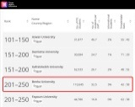
Prof.Dr. Gamal Sosa, BU president announces that the University obtains a high rank as it ranges between the ranks 201-250 among 984 international universities. The university categorizes under the third class among 30 governmental and private universities in the British Times ranking of the Universities (2023) for the fourth year in a row. To get an overview of the full ranking of the universities, kindly visit the following link:
https://www.timeshighereducation.com/world-university-rankings/2023/young-university-rankings
BU president congratulates his Excellency Mr. president/ EL-Sisi on the tenth commemoration of the 30th of June revolution
30-6-2023
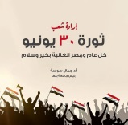
Prof.Dr. Gamal Sosa, BU president congratulate the great Egyptian people and his Excellency Mr. president/ EL-Sisi on the tenth commemoration of the 30th of June revolution stressing that it is the uprising that triggers the will, the challenging spirit and the hope. He also wishes that Egypt is always a prosperous and great country.
Eid Al-Adha Congratulation
26-6-2023
Prof.Dr. Gamal Sosa, BU president congratulates Prof.Dr. Nasser EL-Gizaway, the vice president of post-graduate studies and scientific research, Prof.Dr. Tamer Samir, the vice president of educational and students affairs, Prof.Dr. EL-Sayed Fouda, the vice president of community service and environment development, the faculties’ deans, the vice deans, the administrative heads, the faculties’ members, the employees and the students on the occasion of Eid-Al-Adha.
Emergency alert in the Benha University’s hospitals for Eid-Al-Adha
26-6-2023
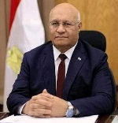
Prof.Dr. Gamal Sosa, BU president stresses that there should be an emergency alert in Benha University’s hospitals during the vacation of Eid-Al-Adha. He also urges that the medications, the doctors and the nurses should be all available just in case of any emergencies and he orders that the patients should be well-treated along with their families to get a high-quality medical service in the University’s hospitals.
The vice president of post-graduate studies and scientific research presides over the workshop of “scientific research ethics” in the faculty of applied arts
26-6-2023
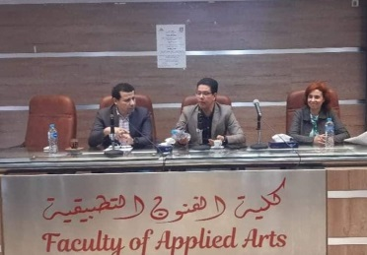
Prof.Dr. Nasser EL-Gizaway, the vice president of post-graduate studies and scientific research presides over the workshop of “scientific research ethics” in the faculty of applied arts in the presence of Prof.Dr. Shams EL-Din EL-Kornfolly, the faculty’s dean. The vice president stresses that the workshop focuses on boosting the awareness of the researchers with regard to scientific research ethics to go in accordance with Egypt vision 2030 and the priorities of the national strategy of the ministry of higher education and scientific research.
BU president hosts a delegation of the Orthodox Church for Eid- Al-Adha congratulation
24-6-2023
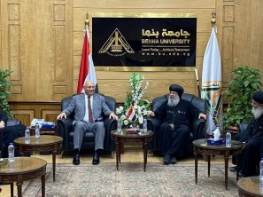
Prof.Dr. Gamal Sosa, BU president hosts a delegation of the Orthodox Church for Eid- Al-Adha congratulation. This is occurs in the presence of Prof.Dr. Nasser EL-Gizaway, the vice president of post-graduate studies and scientific research, Prof.Dr. EL-Sayed Fouda, the vice president of community service and environment development, Ms. Shreen Shawkay, the general-secretary of the university, Mr. Rafaat Nan, the assistant secretary-general of the administrative affairs, the priest, Gerges Zaki, the preist of Virgin Mary’s Church in Benha and the preist, Kozman Sobhy.
BU council honors of the team of the faculty of engineering/ Shubra official page verification
22-6-2023
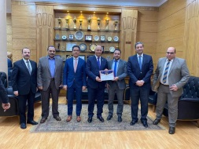
BU council, in its meeting under the presidency of Prof.Dr. Gamal Sosa, the BU president honors of the team of the faculty of engineering/ Shubra official page verification. This is done in the presence of Prof.Dr. Nasser EL-Gizaway, the vice president of post-graduate studies and scientific research, Prof.Dr. Tamer Samir, the vice president of educational and students affairs, Prof.Dr. EL-Sayed Fouda, the vice president of community service and environment development, Ms. Shreen Shawkay, the university- secretary-general , the faculties’ deans, the council members and the assistant secretary-generals.
BU president gets the certificates of quality insurance and the professional safety
22-6-2023
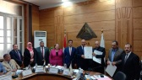
Today, Prof.Dr. Gamal Sosa, BU president gets the certificates of quality insurance and professional safety iso9001-2015 ، ISO45001 2018 after being registered in the international authorities of certification. This is occurred in the presence of Prof.Dr. Nasser EL-Gizaway, the vice president of post-graduate studies and scientific research, Prof.Dr. Tamer Samir, the vice president of educational and students affairs, Prof.Dr. EL-Sayed Fouda, the vice president of community service and environment development, Ms. Shreen Shawkay, the university- secretary-general , the faculties’ deans, the council members and the assistant secretary-generals.
BU council honors the team of E-fingerprint system in the University and the faculties
22-6-2023
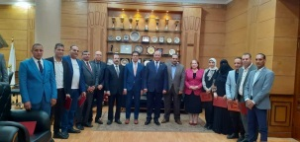
BU council, in its meeting under the presidency of Prof.Dr. Gamal Sosa, the BU president honors of the team of E-Fingerprint system in the University and the faculties who works under the presidency of Mr. Rafaat Nan, the assistant secretary-general of administrative affairs. This is occurred in the presence of Prof.Dr. Nasser EL-Gizaway, the vice president of post-graduate studies and scientific research, Prof.Dr. Tamer Samir, the vice president of educational and students affairs, Prof.Dr. EL-Sayed Fouda, the vice president of community service and environment development, Ms. Shreen Shawkay, the university- secretary-general , the faculties’ deans, the council members and the assistant secretary-generals.
BU president stresses that the University is keen on carrying out the presidential initiative of decent life.
22-6-2023
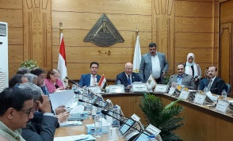
BU council is held under the presidency of Prof.Dr. Gamal Sosa, BU President and in the presence of Prof.Dr. Nasser EL-Gizaway, the vice president of post-graduate studies and scientific research, Prof.Dr. Tamer Samir, the vice president of educational and students affairs, Prof.Dr. EL-Sayed Fouda, the vice president of community service and environment development, Ms. Shreen Shawkay, the university- secretary-general , the faculties’ deans, the council members and the assistant secretary-generals. During the meeting, he stresses that the University is keen on carrying out the presidential initiative of decent life as it’s a national initiative launched by his Excellency/ Mr. President. Abdel Fattah EL-Sisi to improve the life of the Egyptian citizens and boosting the Egyptian state to be prosperous and successful.
Certifying 9 programs in the faculties of engineering/ Shubra and the faculty of education by the national authority of education quality insurance and certification
22-6-2023
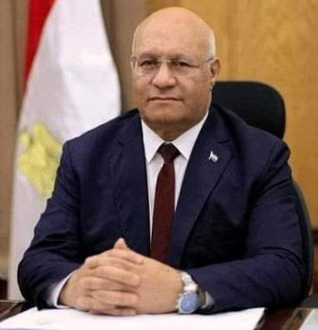
Prof.Dr. Gamal Sosa, BU president says that there are 9 programs of the faculty of engineering/ Shubra and the faculty of education by the national authority of education quality insurance and certification. He thanks Prof.Dr. Ayman EL-Shehaby, the dean of the faculty of engineering/ Shubra and Prof.Dr. Magdy EL-Shahat, the dean of the faculty of education and both faculties’ affiliates for their exerted efforts to get these programs certified. He stresses that the University spares no effort to certify the programs with the national authority of education quality insurance and certification.

